James Dumitru

IIT PSYCH 203

Instructions:

Depict tuition for IIT for the last 10 years, if not, as much as you can.

Make sure you get the source.

Sources:

<https://web.iit.edu/student-accounting/tuition-fees/previous-year-tuition>

^^ These are for the last 8 years

I got the tuition for this semester from my college bill.

IIT tuition since 2010. As you can see it has been increasing by the hundreds and since last semester it keeps on going.

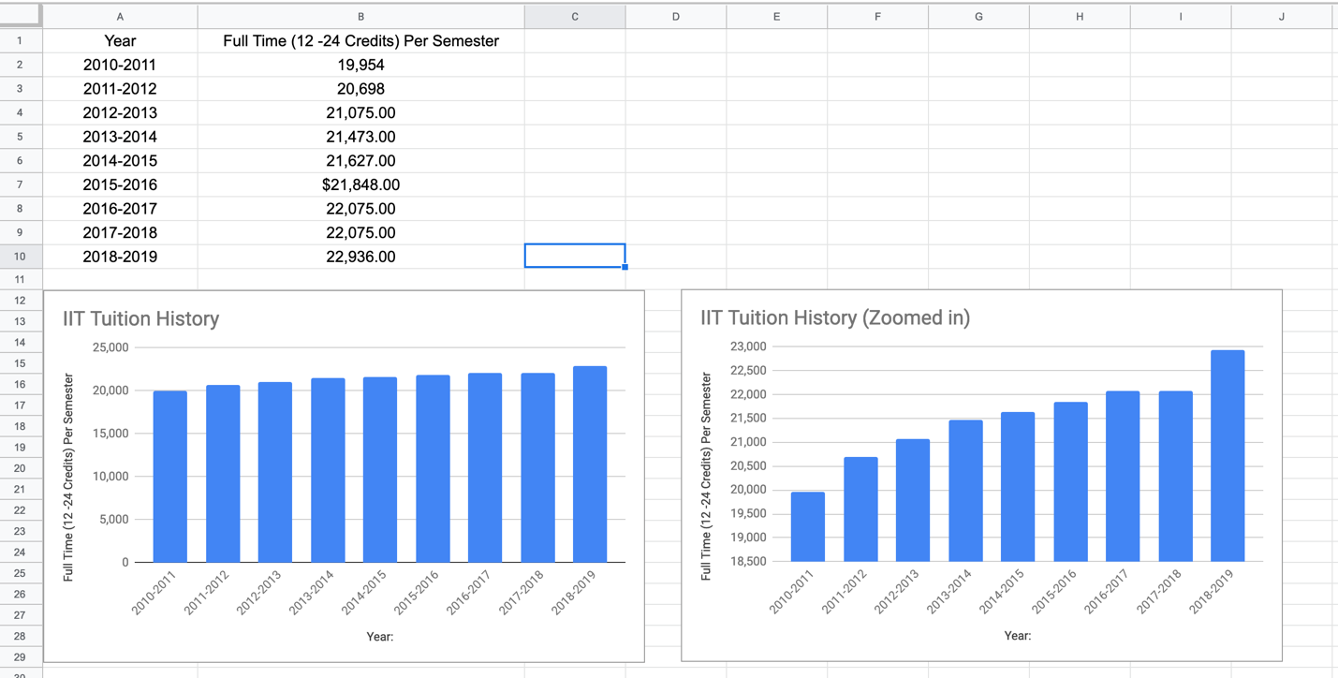

I had a harder time with excel and R studio than I should have; they wouldn't let me alter the x to display the year to year, so I tried Google spreadsheets and it worked fine. I was trying to do a scatterplot because it was easier to read in my opinion. It's not the programs fault and mostly me not knowing how to use them. I had to substitute it for this instead which I believe works fine and easy to read as well.